**Pseudocode for Daylight**

Recap: This is a mobile app designed for people with bipolar disorder, aiming at helping them track their daily mood changes and mark their daily highlight.

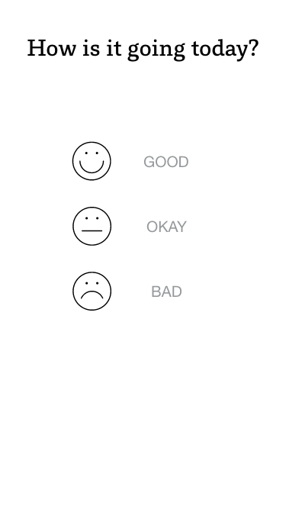

This is the home screen, which is composed of a

label saying, “How is it going?” and three different

basic emotion icons, which are made of buttons.

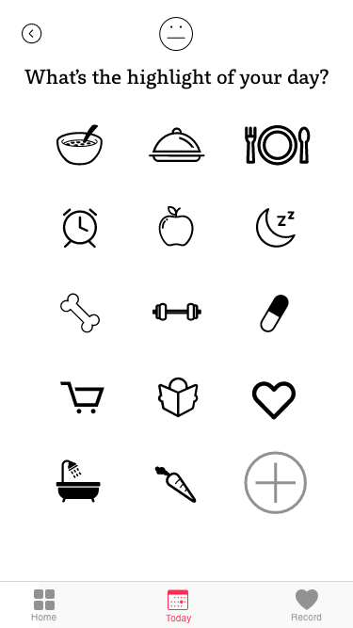

This is the today screen, which is composed of a

back button, a label asking the user about the

highlight, several default icons made of buttons,

a plus button which links to the third screen, and

at the bottom lies a tap bar, allowing the users to

switch between the three screens.

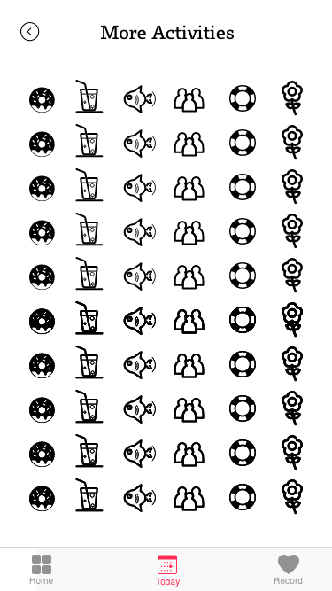

This is the “plus” screen, which is composed of

a back button to the today screen, and

another bunch of icons of the same functions

as in the last screen. Also, there is a tap bar for

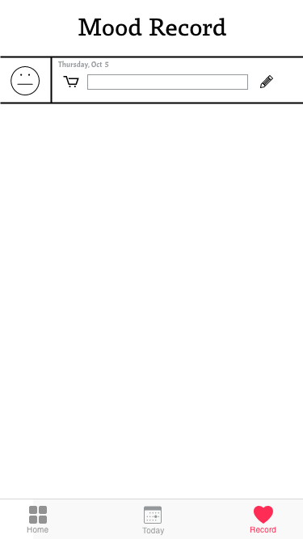 quick switch at the very bottom.

This is the record screen, which is

composed of a label named “Mood

Record” and a list of users previous

choices, including the emotion icon

and the activity icon. Meanwhile, the

specific date will be displayed on the

top of the icon. On the right side, there

is a pencil indicating that the user can

make some notes about their highlight, and

that will work as a textfield. The bottom

part lies a tab bar as well.